CIS 641 IC4

Srinija Reddy Kotla, Yaswanth Babu Komminni, Likhitha Kommineni

State machine

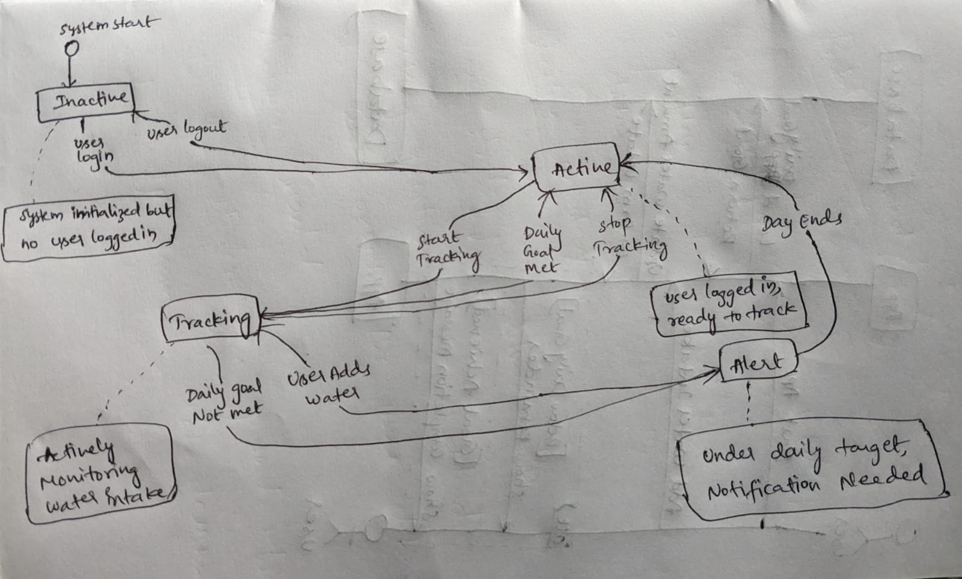

Sequence diagram:

